**Disk Addition in ASM DG**

1. Execute the script

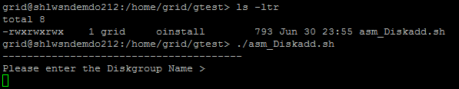

1. Enter the diskgroup name in which we want to add the disk

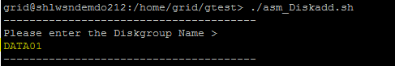

1. Enter the number of disks

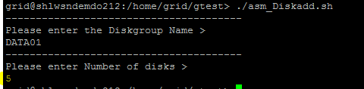

1. Once the script executed, It will generate a SQL file for adding the disks into ASM diskgroup

